Screenshot 1: Watch

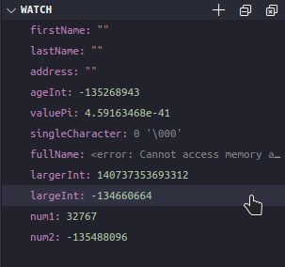

Screenshot 2: Empty varibles

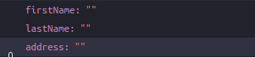

Screenshot 3: Variables already filled with something



Screenshot 4: Breakpoints

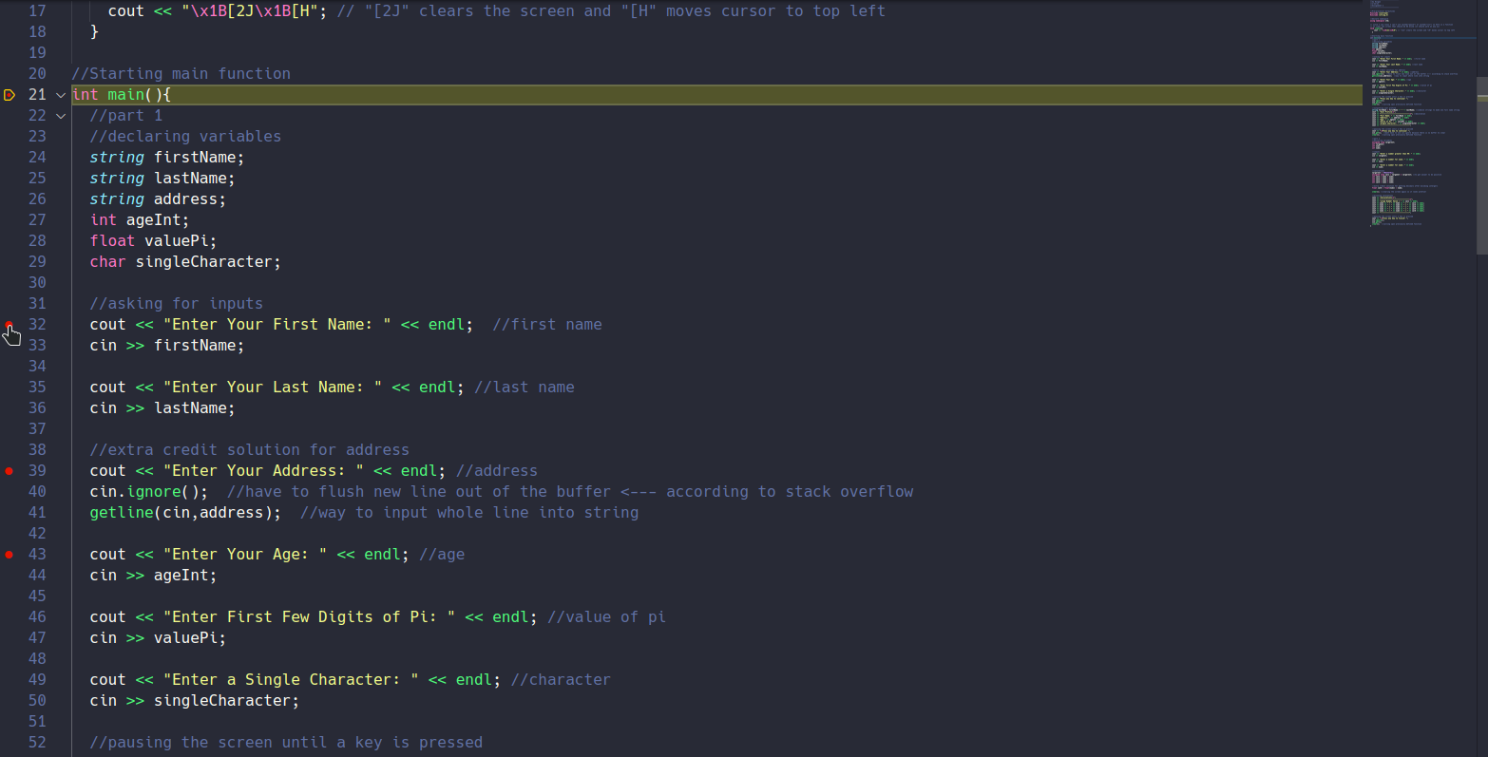

Screenshot 5: Variable (or 2) before a calulation is performed



Screenshot 6: Variable (or 2) after a calulation is performed

